1. 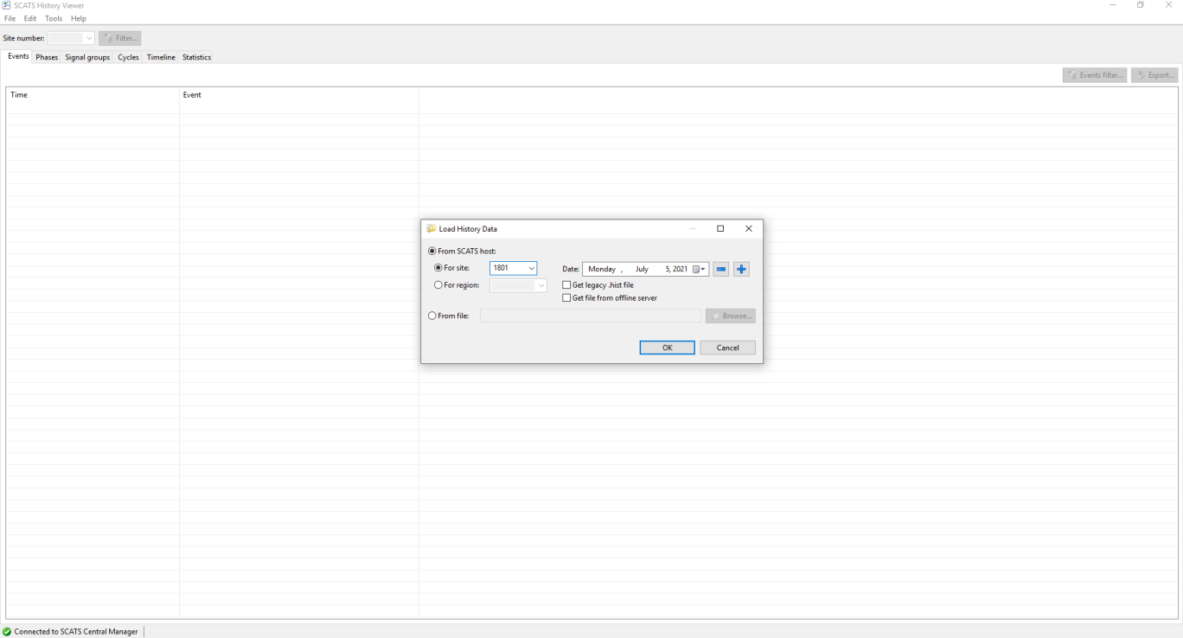Go to each site from SCATS History View and choose the day you want to perform the check on
2. From the “Event” tab make sure you check all the Event types as shown in the figure below by clicking on Events filter and checking all the types.

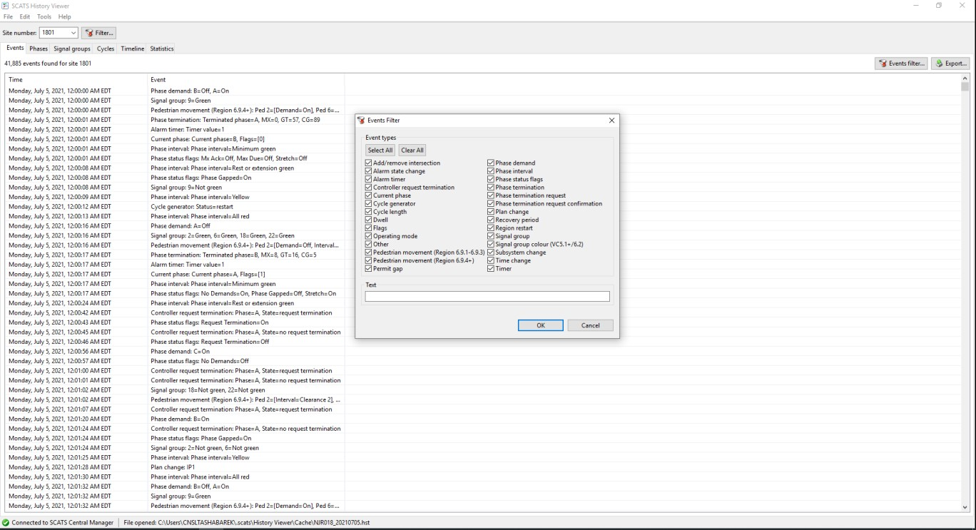

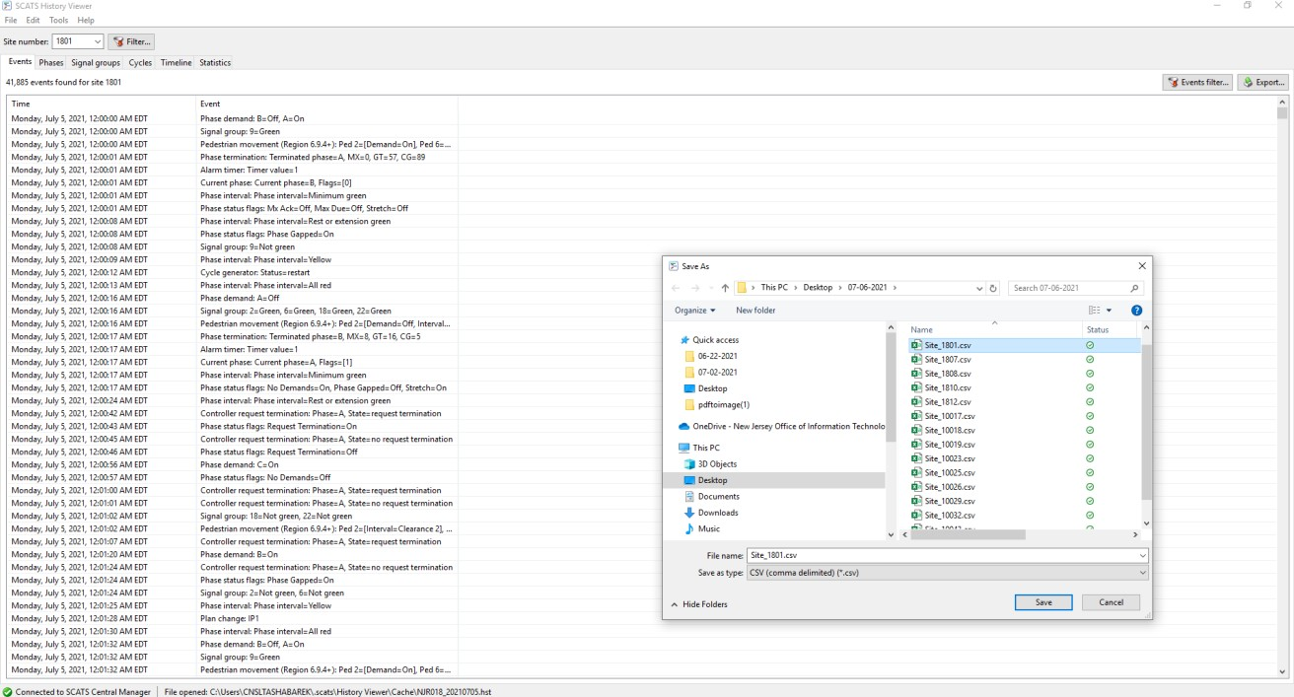needs to be saved as “Site_1801.csv” and keep it in one folder for ease as shown below:

1. Repeat the process for all the intersection you want to check on by changing the site number in History view if it is the same route or clicking File ➔ Load History Data and change the site if it is a different route.
2. Once done with all the sites you need to check, go to this [link](https://abdullahshabarek.shinyapps.io/SCATS_NJDOT_AMC/) and Choose the tab “Max Value Problems” and fill only the parts highlighted in the figure below:

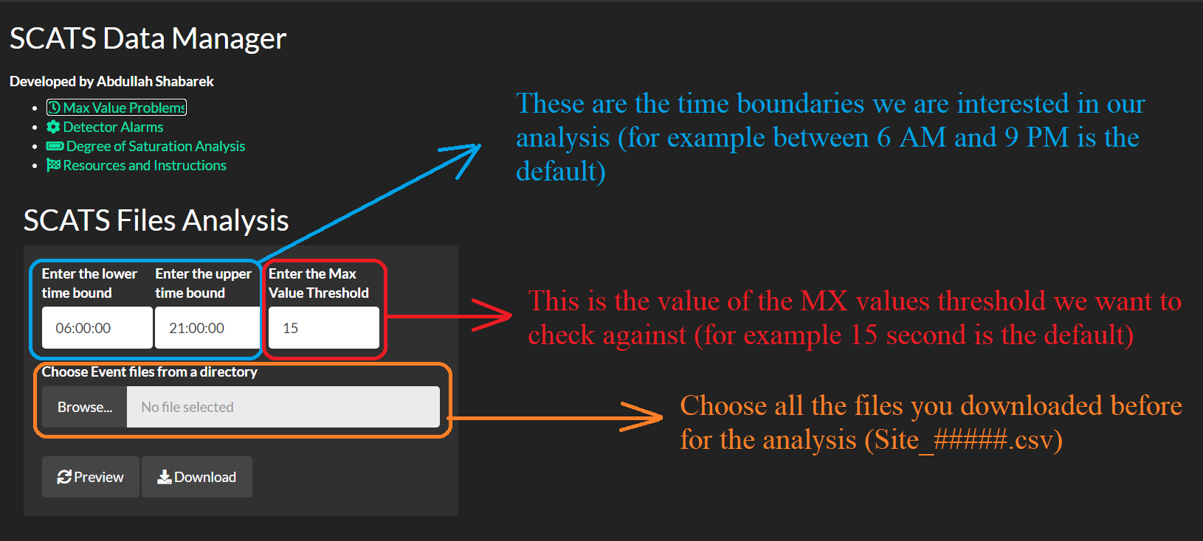

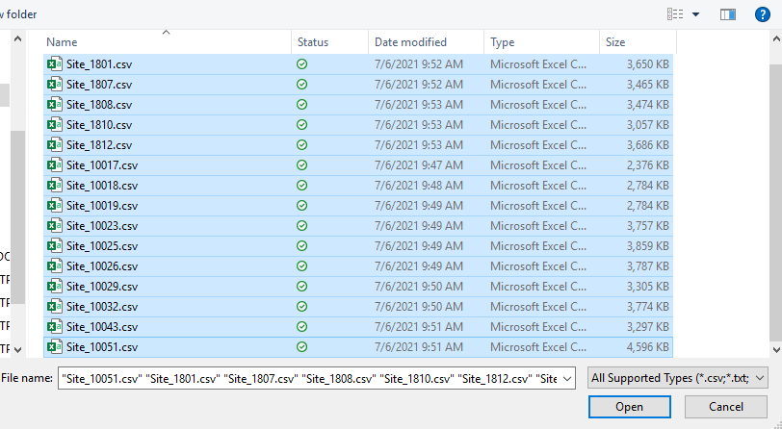

1. Once you choose the files, and depending on how many files, give it around 1 minute and then hit

“Preview” Button if you want to see the heatmap of the critical sites.  
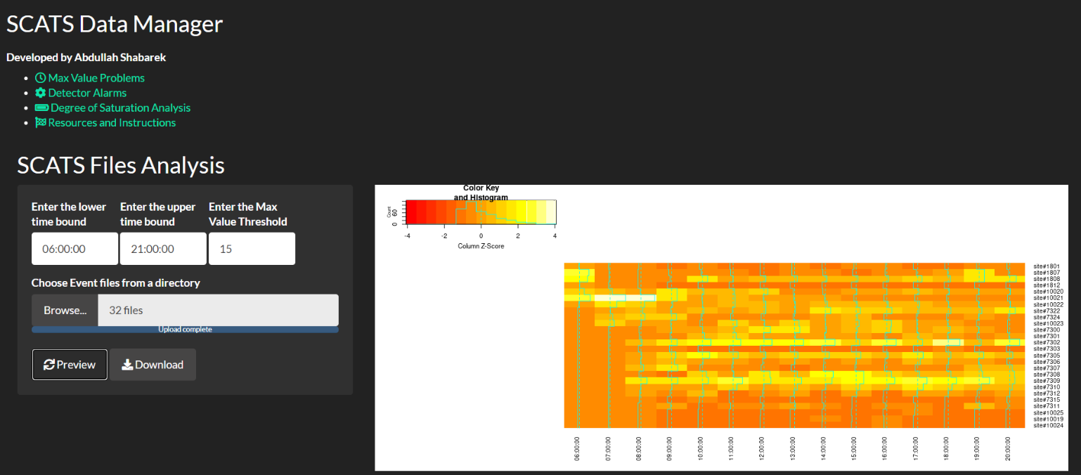

1. To download the data and see the actual numbers of occurrence, hit “Download” button